**Windows 10 UWP – Hands on Lab**

**Lab 6:**

**Note**: This demo app created for this lab uses the Visual Studio 2015 RTM and Windows Tools SDK ver 10240.

1. Open the \View\BBQRecipePage.xaml.cs file and make sure the following using statements match the ones below. Add the missing using statements.

using HowToBBQ.Win10.ViewModels;

using System;

using System.Collections.Generic;

using Windows.Foundation;

using Windows.Media.Capture;

using Windows.Storage;

using Windows.Storage.FileProperties;

using Windows.Storage.Pickers;

using Windows.Storage.Streams;

using Windows.UI.Xaml;

using Windows.UI.Xaml.Controls;

using Windows.UI.Xaml.Media.Imaging;

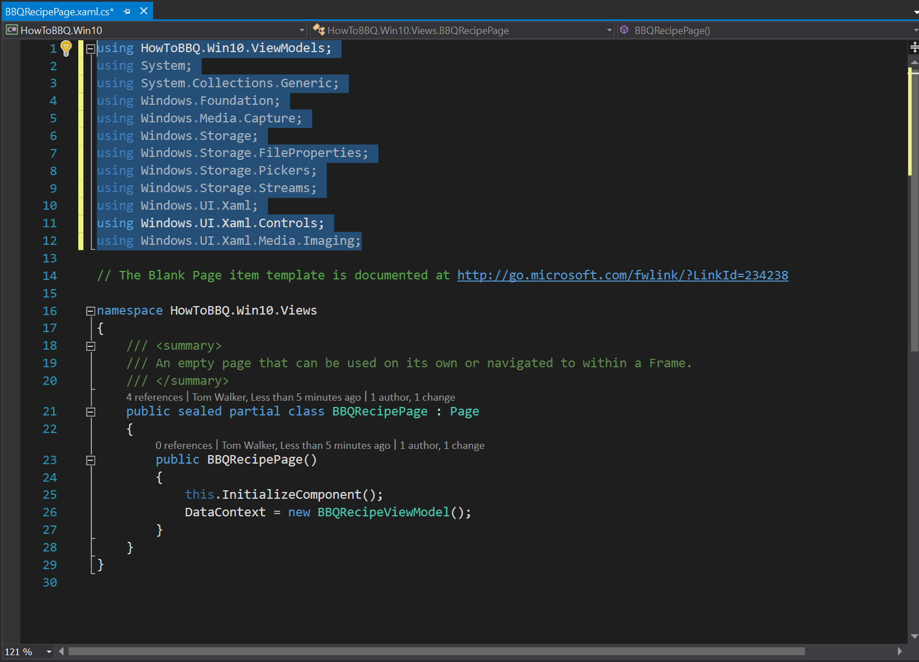

1. In the \View\BBQRecipePage.xaml.cs file and add the following lines of code on line 24.

public MediaCapture captureManager;

public bool isPreviewing = false;

public bool isAutoFocus = false;

private WriteableBitmap bitmap;

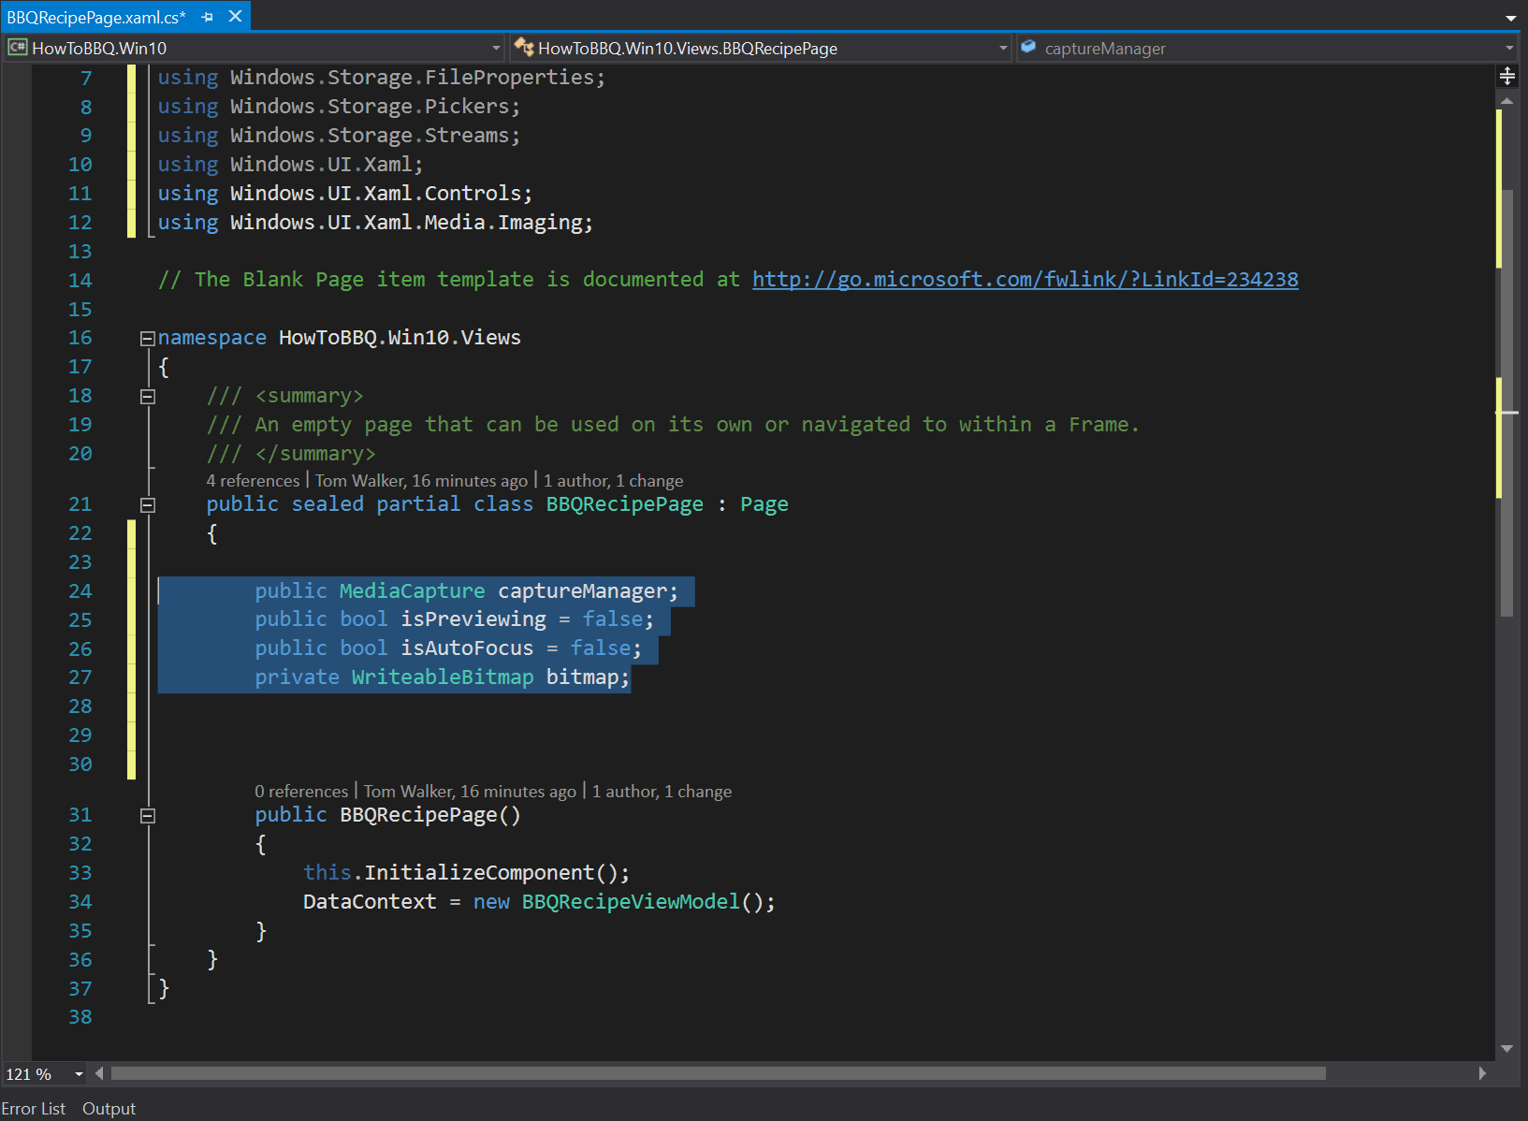

1. In the \View\BBQRecipePage.xaml.cs file and add the following lines of code on line 37.

private async void Loadphoto(string filename)

{

//load saved image

StorageFolder pictureLibrary = KnownFolders.SavedPictures;

StorageFile savedPicture = await pictureLibrary.GetFileAsync(filename);

ImageProperties imgProp = await

savedPicture.Properties.GetImagePropertiesAsync();

var savedPictureStream = await savedPicture.OpenAsync(FileAccessMode.Read);

//set image properties and show the taken photo

bitmap = new WriteableBitmap((int)imgProp.Width, (int)imgProp.Height);

await bitmap.SetSourceAsync(savedPictureStream);

BBQImage.Source = bitmap;

BBQImage.Visibility = Visibility.Visible;

}

private async void ButtonFilePick_Click(object sender, RoutedEventArgs e)

{

var picker = new FileOpenPicker();

picker.ViewMode = PickerViewMode.Thumbnail;

picker.SuggestedStartLocation = PickerLocationId.PicturesLibrary;

picker.FileTypeFilter.Add(".jpg");

picker.FileTypeFilter.Add(".jpeg");

picker.FileTypeFilter.Add(".png");

StorageFile file = await picker.PickSingleFileAsync();

if (file != null)

{

// Application now has read/write access to the picked file

Loadphoto(file.Path);

}

}

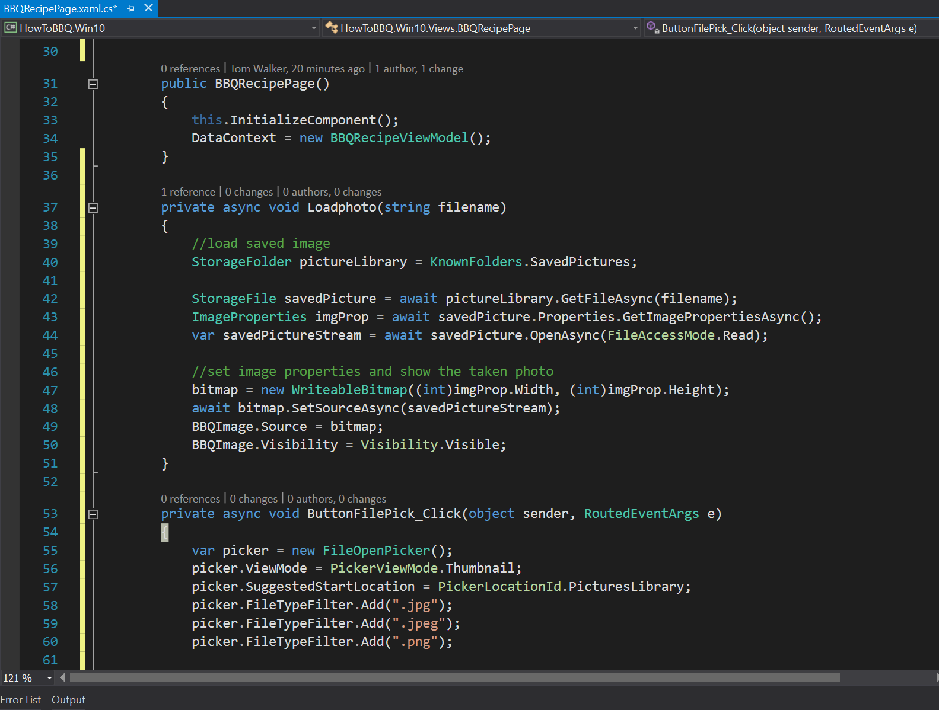

1. In the \View\BBQRecipePage.xaml.cs file and add the following lines of code on line 37.

private async void ButtonCamera_Click(object sender, RoutedEventArgs e)

{

CameraCaptureUI captureUI = new CameraCaptureUI();

captureUI.PhotoSettings.Format = CameraCaptureUIPhotoFormat.Jpeg;

captureUI.PhotoSettings.CroppedSizeInPixels = new Size(600, 600);

StorageFile photo = await

captureUI.CaptureFileAsync(CameraCaptureUIMode.Photo);

if (photo != null)

{

BitmapImage bmp = new BitmapImage();

IRandomAccessStream stream = await photo.

OpenAsync(FileAccessMode.Read);

bmp.SetSource(stream);

BBQImage.Source = bmp;

FileSavePicker savePicker = new FileSavePicker();

savePicker.FileTypeChoices.Add

("jpeg image", new List<string>() { ".jpeg" });

savePicker.SuggestedFileName = "New picture";

StorageFile savedFile = await savePicker.PickSaveFileAsync();

if (savedFile != null)

{

await photo.MoveAndReplaceAsync(savedFile);

}

}

}

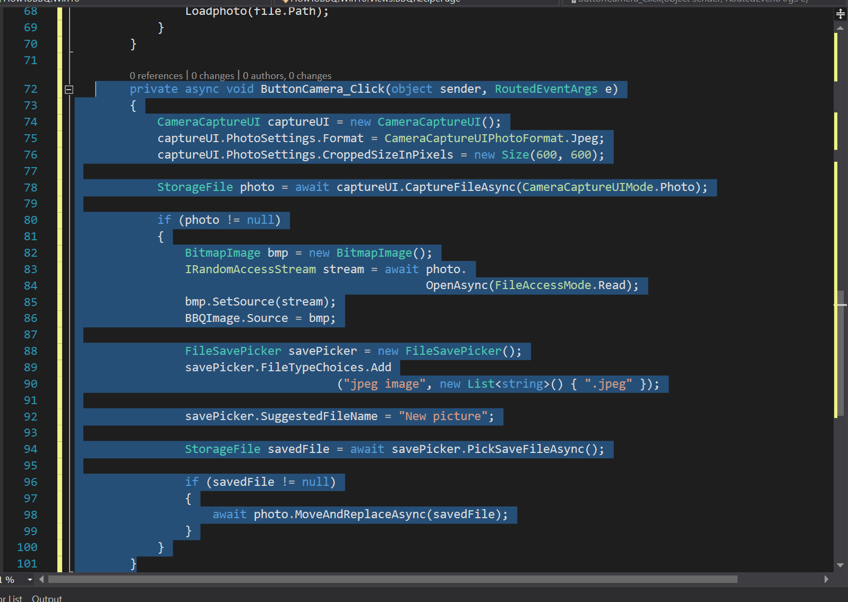

1. Open the \View\BBQRecipePage.xaml file and add the following lines of xaml code on line 63.

<StackPanel Margin="0,20,0,0" Orientation="Horizontal"

HorizontalAlignment="Center">

<Button Margin="10" x:Name="ButtonFilePick" Content="Select Image"

FontSize="32" Click="ButtonFilePick_Click">

<Button.Background>

<LinearGradientBrush EndPoint="0.5,1"

StartPoint="0.5,0">

<GradientStop Color="#FFDC9743" Offset="0.171"/>

<GradientStop Color="#FF0A0A0A"/>

<GradientStop Color="#FF0A0A0A" Offset="0.98"/>

<GradientStop Color="#FFDC9743" Offset="0.949"/>

</LinearGradientBrush>

</Button.Background>

</Button>

<Button Margin="10" x:Name="ButtonCamera" Content="Camera"

FontSize="32" Click="ButtonCamera_Click">

<Button.Background>

<LinearGradientBrush EndPoint="0.5,1"

StartPoint="0.5,0">

<GradientStop Color="#FF4293CE" Offset="0.171"/>

<GradientStop Color="#FF0A0A0A"/>

<GradientStop Color="#FF0A0A0A" Offset="0.98"/>

<GradientStop Color="#FF4293CE" Offset="0.949"/>

</LinearGradientBrush>

</Button.Background>

</Button>

</StackPanel>

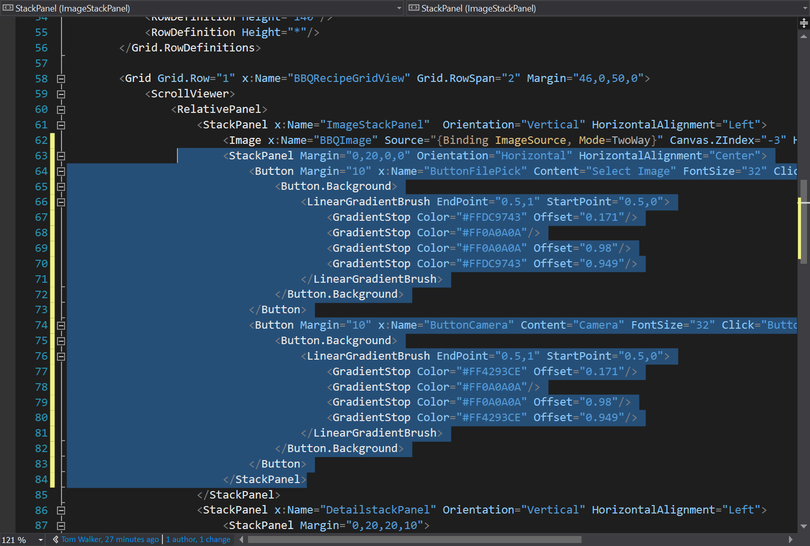

1. Double click on the file “Package.appxmanifest” to open the App Manifest widow. Make sure to enable “Video Library”, “Picture Library”.
2. 